Fire Chiefs' Association of Massachusetts, Inc

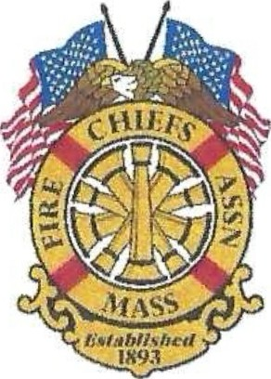
General Membership Meeting Agenda
November 19, 2025
0900 hours Coffee /Vendors
1000 hours meeting
NFPA
1 Batterymarch Park, Quincy

Meeting Opened at: 1000 hrs. by Chief Purcell

Pledge of Allegiance:

Chaplain Rev. Bruce Arbour: Sickness & Distress: None

Deaths:
- Chief Leonard J. Redfern, Ret. Reading Fire Department

Approvement of the previous meeting:
Minutes of October 30, 2025, General Membership meeting, distributed by email.

Vote:

Applications for Membership -

- Deputy Fire Chief Brenden Ramsey, Mashpee Fire & Rescue Department, recommended by Fire Chief Peltier, Mashpee FD
Vote:

Applications for Life Membership Life – none
GUEST PRESENTATION:
Welcome from NFPA

Chief Patrick Purcell – President
- Single Staircase
- Secretary of Public Safety
- EMS/Hospital Linen
- Public Relations/DFS
- New England Division Representative

Chief Brian Nardelli -1st VP
- PDC/NE Division
- PFAS update

Chief Christopher Norris - 2nd VP
- DCF Resource Centers

Chief Michael Kelleher- lPP

Secretary/Treasurer - Chief Kevin Partridge, Ret.

Correspondence/Information:

- Letter received from MEMA Director Dawn Brantley making the appointments of Chiefs to the State Fire Mobilization Committee
- Letter received from Essex County Fire chiefs in support of House Bill 2689
- CFSI Survey has gone out to the membership, please sign up if you plan to attend
- PDC Attendee registrations open in November
- The BOD approved funding for the Meet & Greet, Networking Reception at the PDC

Treasury
Bank Balances as of November 15, 2025
Chase Bank:
  - Checking $ 1,000.00
  - CD1 (4286)4month 8-11-25 $137,623.36maturitydate1-11-26
  - CD 2 (4287) 4 month 8-11-25 $136,966.22 maturity date 1-11-26

Assets Chase Bank = $275,589.57

BayCoast Bank:
  - Checking Operating $ 23,661.25
  - Checking Legal Defense $ 23,787.50
  - Money Market $271,103.61
Assets at BayCoast Bank = $ 318,552.36

Quickbooks checking = $ 19,380.50

Total assets: $ 613,522.43

Vote:
Government Affairs Director- Chief Bill Scoble, Ret.
  - Legislative Update

State Fire Marshal - Jon Davine
- DFS Updates
Reports of Committees

- Civil Service - Chief Gentile
- IAFC - Chief Burke
- Fire Mobilization - Chief Hurlbut
- Tech Rescue - Chief Belsito
- Haz Mat - Chief Bailey
- State 911- Chief Kelleher
- Utilities - Chief Nardelli
- EMS - Chief Normandin
- DEI - Chief Kelly
- Mass Fire Training Council - Chief Madden
- Mass Fire Service Commission – Chief Ingram
- Professional Development Conference- Chief Partridge

Unfinished Business

New Business

Remarks for the Good of the Association

Next regularly scheduled meeting
- December 17, 2025, Christmas Luncheon, Noon, Renaissance Hotel, 28 Patriot Place, Foxborough
- January 21, 2026, Virtual Meeting

Adjourn at:

