Fire Chiefs' Association of Massachusetts, Inc

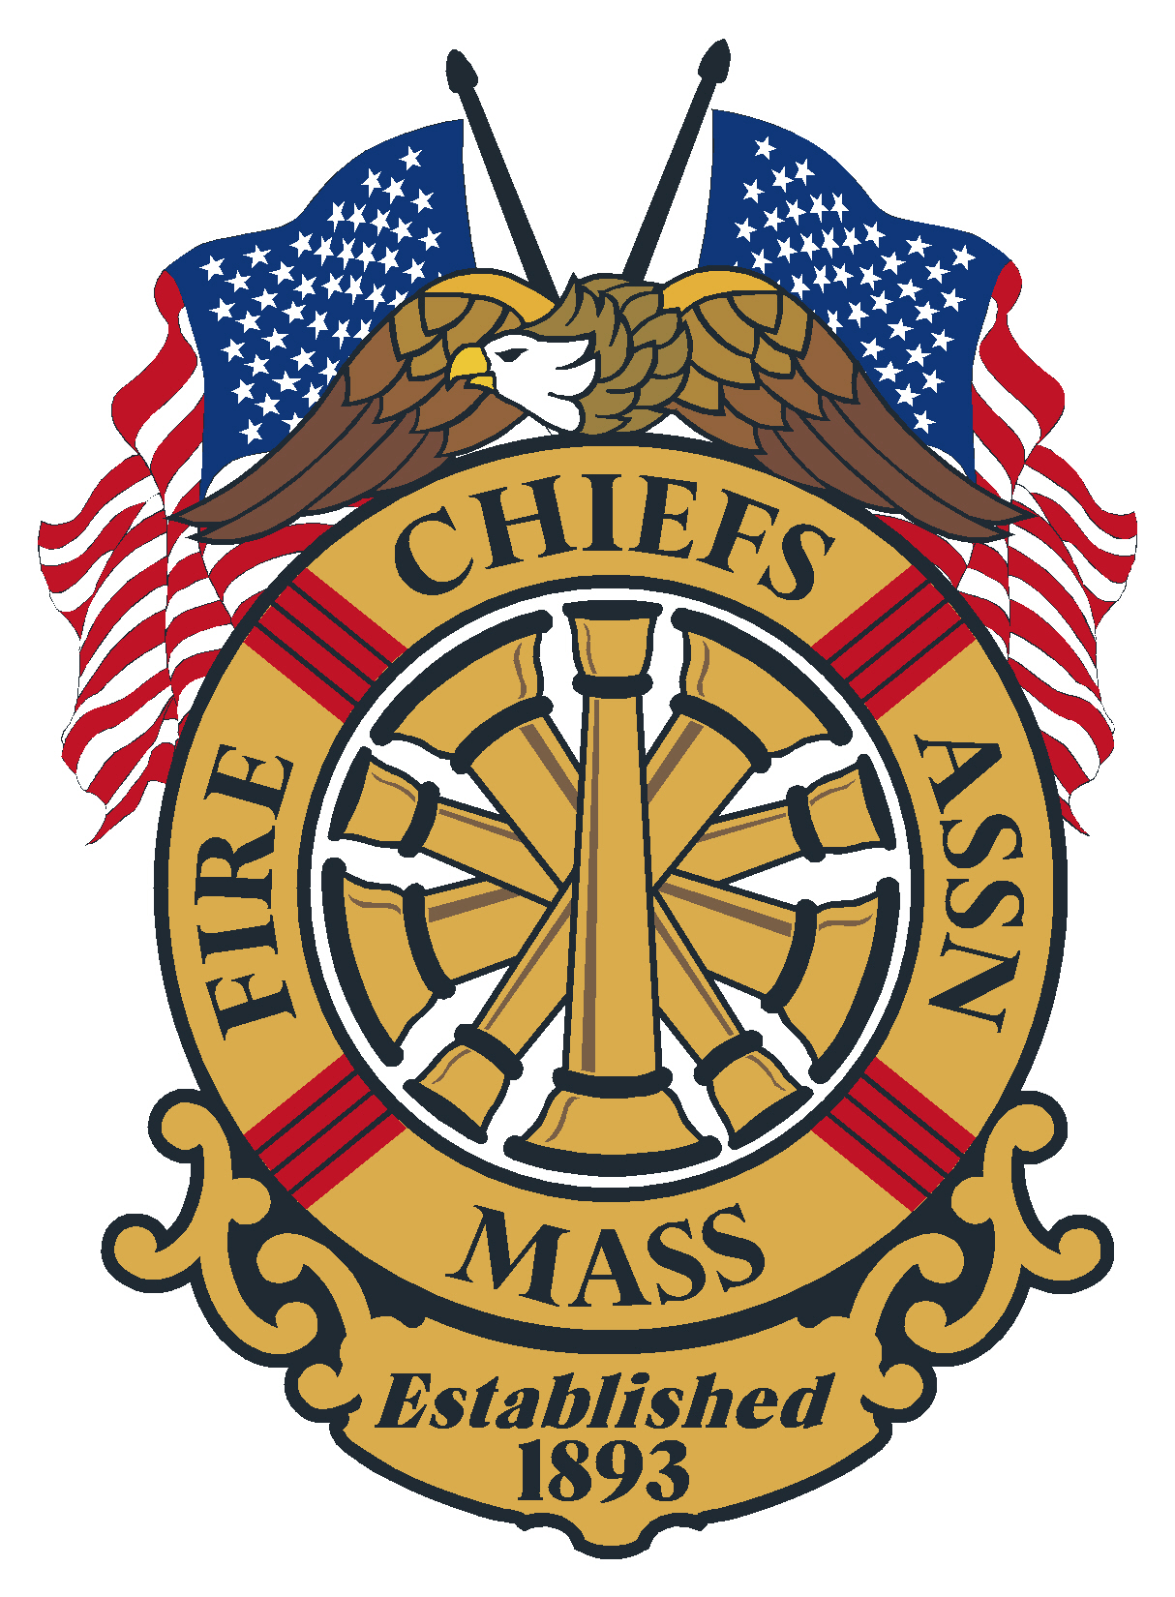

General Membership Meeting
Agenda
June 18, 2025
Crumpin Fox Golf Course
Bernardston, MA, MA

Meeting opened at: by Chief Kelleher President

Pledge to the Flag: Chief

Sickness & Distress : Deputy Chief Chaplain Rev. Dan Valerie, Southwick FD

Deaths :
- Chief John Greene ret. Montague Center Fire Department
- FF Jeffrey Jeffrey Deschense, North Andover Fire Department
- Chief Geoffrey Gardell Ret. Worcester Fire Department
- Captain Andrew Porter, Rockport Fire Department

Minutes of the previous meeting: Minutes of the General Membership meeting held March 19, 2025, were sent out to the membership via the FCAM email/post.

Vote:

Applications for Membership

- Fire Chief Jeffrey Dias, Williamstown FD, recommended by Chief John Kelley, Wareham FD
- Deputy Chief Michael Gulla, Holliston FD, recommended by Assistant Chief Brian Kelley, Holliston FD
- Deputy Chief Brian Garland, Blackstone Fire Department, recommended by Chief Kevin Roy

Vote:

Applications for Life Membership Life

Vote:

Special Guests: Mayor J. Christian Dumias, Marlborough MA, Welcome to Marlborough

Chief Patrick Purcell – President
- Public Safety Leadership Academy
- Training
- Email
- Bulletins
- Newsletter
- BFPR Seats
- Civil Service
- Audit

Chief Brian Nardelli – 1st VP
- Legal Defense Attorney program
- EMA Legislation

Chief Christopher Norris – 2nd VP
- EMS Licensing and Vaccines
- Lithium Ion concealed batteries

Chief Michael Kelleher– IPP

Secretary/Treasurer – Chief Kevin Partridge, Ret.

Correspondence: none

Treasury
As of April 4, 2025

Baycoast Bank:
- Checking- Operating $ 13,649.84
- Money Market $ 217,786.84
- Legal Defense $ 24,150.00

Assets Citizens Bank = $255,586.68

Chase Bank:
- Checking $ 1,000.00
- CD 1 2 month $ 135,832.00
- CD 2 2 month $ 135,183.43

Assets Chase Bank = $272,015.43

Quickbooks = $ 673.67

Total assets: $ 528.275.78

Vote:

Government Affairs Director- Chief Bill Scoble, Ret.

State Fire Marshal – Jon Davine

Reports of Special Committee

- Civil Service – Chief Stark

- IAFC – Chief Stark

- Haz Mat – Chief Bailey

- EMS – Chief Norris

- Tech Rescue – Chief Belsito

- Fire Mobilization – Chief Hurlbut

- Call/Volunteer –

- State 911 – Chief Kelleher

- DEI Committee – Chief Kelly

- Utilities – Chief Nardelli

Unfinished Business

New Business

Remarks for the Good of the Association

Next regularly is scheduled meeting:
- August 20, 2025 Virtual Meeting
- September 17, 2025 Spinelli’s, Lynnfield

Meeting Adjourn at:

