Fire Chiefs' Association of Massachusetts, Inc

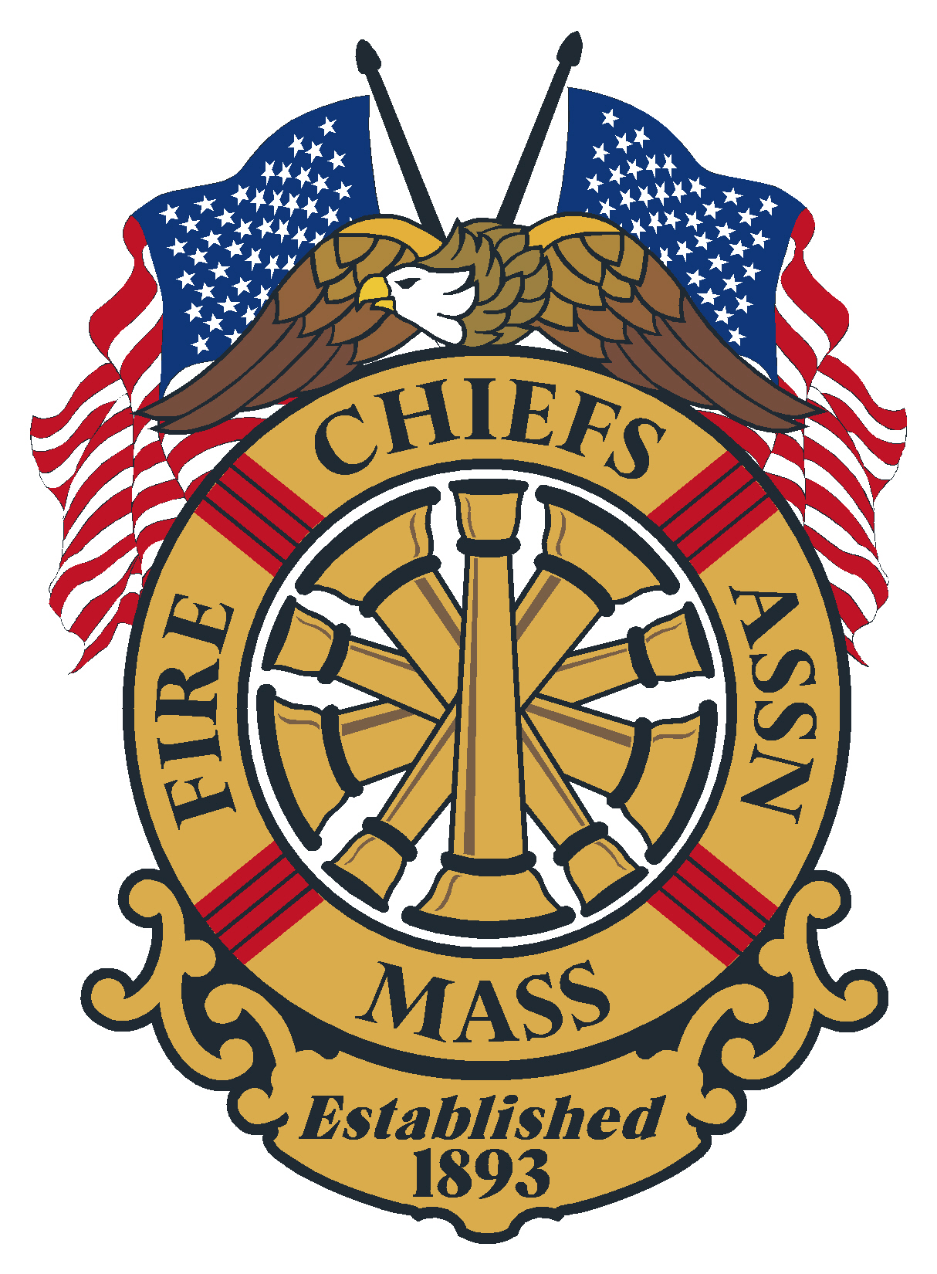

General Membership Meeting
Agenda
April 9, 2025
Fire Fly’s Marlborough, MA

Meeting opened at: 10:25 by Chief Kelleher President

Pledge to the Flag: Chief Kelleher

Sickness & Distress : Rev. Bruce Arbour

Deaths :
- Chief Michael J. Bradford, Sr. ret. Upton Fire Department

Minutes of the previous meeting: Minutes of the General Membership meeting held March 19, 2025, were sent out to the membership via the FCAM email/post.

Vote: Approved

Applications for Membership

Vote: none

Applications for Life Membership Life

Vote: none

Special Guests: Mayor J. Christian Dumias, Marlborough MA, Addressed the group and welcomed us all to Marlborough.

Chief Michael Kelleher – President –

- Medicare/Medicaid Crossover Payments
- Tech Rescue Legislation – Board voted to not change the language
- FEMA Grants – FCAM and IAFC are working on this
  - Some grants have not been paid since February
- EMA bill has been filed and looks to have some problems for fire chiefs
- October FCAM monthly meeting will be in Connecticut and coincide with the NEDIAFC meeting on October 30th.

Chief Patrick Purcell– 1st VP
- BFPR positions – need for 50K+ and 25K+
- Civil Service position
- MA Fire Service Commission – sent in two names
- EMS – Amb. Inspections - Chief Norris sent out a form to follow

Chief Brian Nardelli – 2nd VP
- Legal Defense Fund – discussed setting it up more like the MA Police Chiefs system

Chief Peter Burke – IPP
- IMT
- EMAC

Secretary/Treasurer – Chief Kevin Partridge, Ret.

Correspondence: none

Treasury
As of April 4, 2025

Baycoast Bank:
- Checking- Operating $ 28,507.08
- Money Market $ 279,085.65
- Legal Defense $ 24,150.00

Assets Citizens Bank = $331,742.73

Chase Bank:
- Checking $ 1,000.00
- CD 1 2 month $ 135,832.00
- CD 2 2 month $ 135,183.43

Assets Chase Bank = $272,015.43

Quickbooks = $ 5,508.76

Total assets: $ 609,266.92

Vote: Approved

Government Affairs Director- Chief Bill Scoble, Ret.
- Most Bills have numbers and have been assigned to Committee. The House Budget is due by May 14th and then will head over to the Senate. The big issue we’re watching is the elimination of the Medicare/Medicaid “pop-up” option. This represents about 30 million dollars to the ambulance services in the State.
- Fire Equipment Grants – MBTA Communities will get their Grants.
- The FCAM priorities list is completed and is available for anyone that may be speaking with their Representative or Senator. As these Bills progress, we need to have the proper representatives from our organization identified and prepared to testify at Hearings. Please contact me if you need a copy.
- Hearings have started – Public Health has one scheduled – included are several Bills requiring AEDs at all athletic fields, sporting events, and health clubs. Public Safety has one, no FCAM priority Bills are included, however there are several that we need to track including Bills : 1) that would mandate American Sign Language training for FF’s, EMTS’s, and police, 2) would require anyone storing and/or selling automotive batteries to post a notice, 3) the requirement for all emergency vehicles to be equipped with an emergency thermal blanket.
- IPP Burke contacted me regarding Bills that have been filed regarding the enabling legislation and authorities of MEMA, and a legislative rally that EMD’s are having. The proposed changes have far reaching effects including eliminating all of the old Civil Defense Laws and creating IMAT Teams. FCAM was never consulted regarding these changes. The organizer is the Emergency Management Director from Suffolk University.
- On March 31st I attended a meeting on the Cape with Rep. Hadley Luddy from Orleans, Senator Julian Cyr, several Cape Chiefs and the father of a woman who was killed, along with her daughter, in a fire in a VRBO house in upstate New York. The reason for the meeting is a Bill that has been filed that would require inspections by the local fire department for all short-term rentals (VRBO, Air BnB, etc.) to ensure compliance with the smoke detector and CO alarm requirements. The Bill would also require the online platforms to require and post the certification. There is an inspection fee schedule of $100 per unit and $500 per building included in the Bill. The requirements on Fire Departments to perform these inspections is obviously a concern, especially for areas like the Cape, Boston, and the Berkshires. A survey has been sent out, there is some great information from the Cape and the Berkshires, more is needed.
- The Federal Issues – the closing of the NFA and FEMA, and the pausing of the SAFER and AFG programs are still unresolved. Also, the NIOSH Firefighter Death Investigation unit has been closed, along with the Firefighter Cancer Registry and the New York 9/11 impact offices. I had a long discussion with the Legislative Director of the IAFC – Ken LaSala regarding all of these issues. He forwarded to me the supposed matrix for reviews of the different grant programs to review all grants to be sure they conform with the administration’ s priorities. Please watch the IAFC and CFSI websites. A survey was sent out, there was a great return highlighting the delays and what Chiefs are being told by their grant administrators.
- We are trying to set up meetings with New Chairs of PS & HS – Rep. Cahill from Lynn and Senator Cronin from Gardner. Also, Chief Madden is trying to set up a meeting with Senator Driscoll from Milton, the vice-chair of the Committee.
- Communication from Director Hurlbut to consider the request of Royalston Chief Eric Jack to support the Bill to grant a local option property tax exemptions of $2500 to call/volunteer firefighters and EMT’s.
- I’ve been working with Metro Director Dave Frizzell to set up their Legislative Breakfast at the State House – we will ask Rep. Cahill to host and suggest a date.
- CFSI dates for 2026 are March 18th and 19th – a Wednesday and Thursday. We would like to increase the number of chiefs attending and especially try to increase the Chiefs from the Congressional Districts that were not covered this year.
- Attendance by Massachusetts Chiefs at the NED – IAFC meeting is of utmost importance – we need to do all we can to get our people to take the trip to Connecticut.

State Fire Marshal – Jon Davine
- Email went out on a bad hood cleaning company M&M
- New NIFRS system being rolled out. Larger department first
- Conducting interview for an Academy Director
- SAFE Grants went out April 9th
- Cancer Screening – meet with PFFM
  - Some issues with regulations and mandatory training
  - Change to just form based to get more FF through the program
  - If you worked in MA as a FF for more than 5 years you can get the screening
- Director Jeff Winn is retiring as HAZ MAT Director
- Changes in the State FIU
- FF of the Year – get your submissions in

Reports of Special Committee

- Civil Service – Chief Stark

- IAFC – Chief Stark

- Haz Mat – Chief Bailey

- EMS – Chief Norris

- Tech Rescue – Chief Belsito

- Fire Mobilization – Chief Hurlbut – had a meeting March 26th

  - Updated ICS fillable forms

- Call/Volunteer –

- State 911 – Chief Kelleher

- DEI Committee – Chief Kelly

- Utilities – Chief Nardelli

Unfinished Business - none

New Business - none

Remarks for the Good of the Association - none

,Next regularly is scheduled meeting:
- May 21, 2025 Annual Meeting, Swearing in of Officers
Double Tree Hotel, 5400 Computer Sr. Westborough

Meeting Adjourn at: 11:20AM

