SCHEDULE 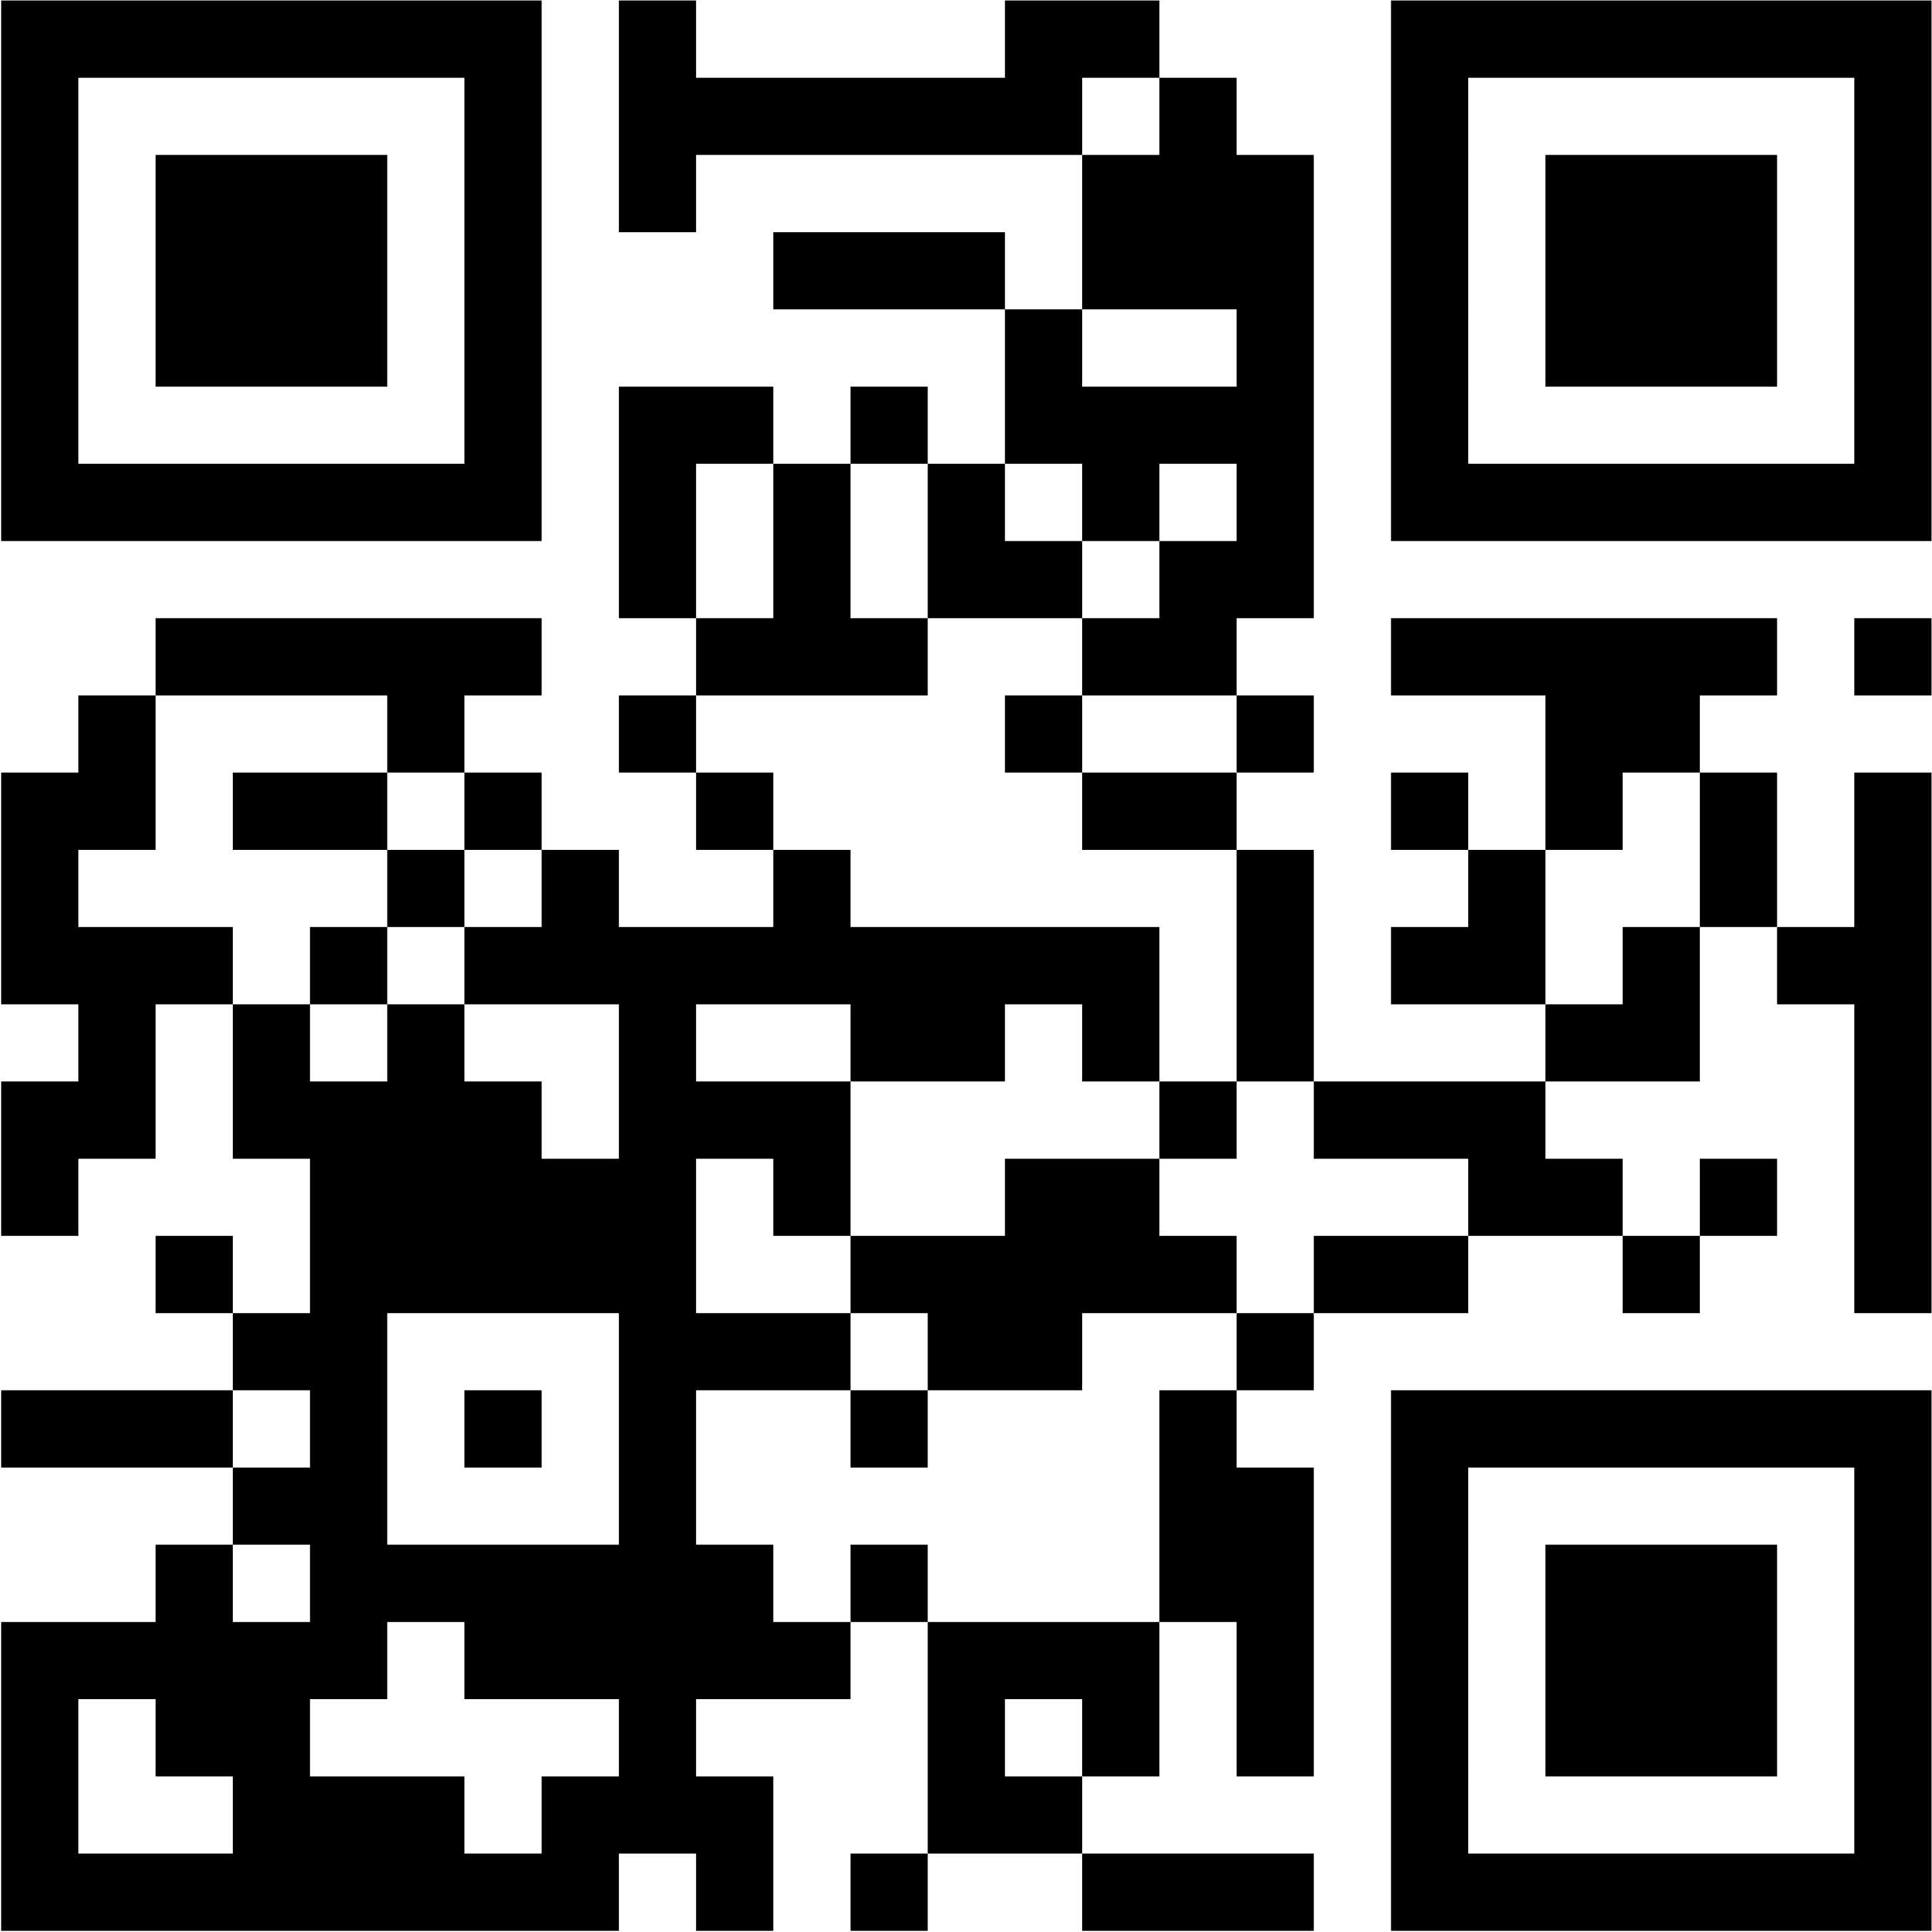

|  |  |  |
| --- | --- | --- |
| **TUES. FEB. 25** | **EXHIBIT HALL** | **MEETING RM A** |
| 0800 - 0900 | ***Registration • Coffee & Pastries • Vendor Area Open 0800 - 1600*** | |
| 0900 - 1000 | **Chief Linskey -** *Leadership and Marathon Bombing* | **NEFAMA** |
| 1010 - 1030 | break | |
| 1030 - 1130 | **Chief Linskey -** *Leadership and Marathon Bombing* | **NEFAMA** |
| 1130 - 1200 | **BREAK / Reset for Lunch • Vendor Area Open** | |
| 1200 - 1315 | ***LUNCH & VENDOR AREA OPEN*** | |
| 1315 - 1445 | **Chief Billy Goldfeder -** *Senior Officer to Newest* | **NEFAMA** |
| 1445 - 1500 | break | |
| 1500 - 1600 | **Chief Billy Goldfeder -** *Senior Officer to Newest* | **NEFAMA** |
| 1600 - 1700 | ***Vendor Area, Social Hour, & Raffles*** | |
| 1800 - 2300 | ***NETWORKING EVENT AT HILTON • LOCATED ON 2nd FLOOR*** | |

|  |  |  |
| --- | --- | --- |
| **WED. FEB. 26** | **EXHIBIT HALL** | **MEETING RM A** |
| 0800 - 0900 | ***Registration • Coffee & Pastries Vendor Area Open 0800 - 1330*** | |
| 0900 - 1015 | **Chief Dr. Sabrina Cohen- Hatton, West Sussex London** *Life and Death Decisions* | **NEFAMA** |
| 1015 - 1045 | break | |
| 1045 - 1145 | **Chief Alan Sirois**  *AI for Fire Service Leaders* | **NEFAMA** |
| 1215 - 1315 | ***(1145 - 1215 set up)***  ***LUNCH & VENDOR AREA OPEN***  ***(seminar moves to upstairs ballroom)*** | |
| 1330 | ***\*Vendor Area Closes\**** | |
|  | **BALLROOM** | **MEETING RM A** |
| 1330 - 1430 | **Simon Sinek**  *Global Best Selling Author* | **NEFAMA** |
| 1430 - 1445 | break | |
| 1445 - 1600 | **Coach Bill O’Brien** | **NEFAMA** |

|  |  |
| --- | --- |
| **ADMIN PROGRAM** | **MEETING RM B** |
| 0800 - 0900 | ***Registration*** |
| 0900 - 1015 | **Streamlining Admin Mastery**  **Jennifer Vincent** |
| 1015 - 1045 | break |
| 1045 - 1145 | **Streamlining Admin Mastery**  **Jennifer Vincent** |
| 1145 - 1330 | **LUNCH** |
| 1330 | ***\*Vendor Area Closes\**** |
| 1330 - 1500 | **Power Up with Outlook**  **Jennifer Vincent** |

|  |  |  |
| --- | --- | --- |
| **THUR. FEB. 27** | **BALLROOM** | **MEETING RM A** |
| 0800 - 0900 | ***Registration • Buffet Breakfast Upstairs Ballroom*** | |
| 0900 - 1030 | **Chief Bill Greenwood - Change Maker Mindset** | **NEFAMA** |
| 1030 - 1045 | break | **NEFAMA** |
| 1045 - 1200 | **Adam Barowy - Lead Researcher UL, Tactical Considerations** | **NEFAMA** |