Fire Chiefs' Association of Massachusetts, Inc

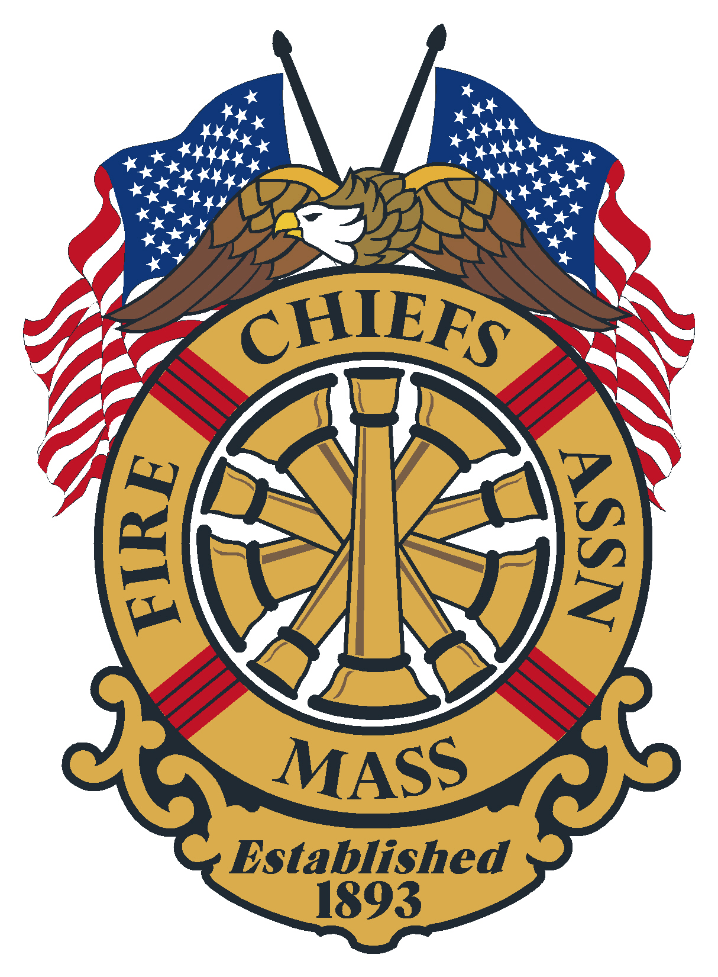

General Membership Meeting
Minutes of November 20, 2024
Virtual Meeting (73 Attendees)

Meeting opened at: 1000 hrs. by Chief Michael Kelleher

Pledge of Allegiance:

Invocation & Sickness/Distress – Chief Kevin Partridge

Sickness –
- Deputy Fire Chief Tony Genga- Northbridge

Deaths –
- Chief Rev. Allen P Hoyt, Ret.
- Abbie McLaughlin, daughter of Chief Michael McLaughlin Ret. Stow, Liaison to the MA Corp. of Fire Chaplains

Minutes of the previous meeting: Minutes of the General Membership meeting held on October 16, 2024, were sent out to the membership via the FCAM News Flash.

Vote: Approved

Applications for Membership
- Deputy Chief Nicholas Grasso, Whitman Fire Department, recommended by Chief Tim Clancy
- Deputy Chief Patrick Reilly, Scituate Fire Department,
Recommended by Scott Duffy, Rockland Fire
- Fire Chief Gary Daugherty, Hopkinton Fire Department, recommended by Chief Kevin Partridge
- Deputy Chief Robert Provost, Bellingham Fire Department, recommended by Chief Bill Miller
- Deputy Chief Michael Rogers, Centerville-Osterville Marston Mills Fire Department, recommended by Chief Byron Eldridge
- Deputy Chief Shawn Clark, Wellfleet Fire Department, recommended by Chief Dave Leblanc
- Deputy Chief Erik Spahl, Dudley Fire Department, recommended by Chief Dean Kochanowski

Vote: Approved

Application for Life Membership:
- Fire Chief Richard Patterson, Dracut Fire Department, recommended by Chief Kevin Partridge
- Deputy Chief Paul Konieczny Ret. Dudley Fire Department, recommended by Chief Kochanowski
Vote: Approved

Chief Mike Kelleher- President

- Had a meeting with DPW Municipal Waste Group- discussions on battery recycling legislation to keep batteries out of the waste stream
- Attended the MA Corps of Fire Chaplains Anniv.
- Update on current wildfires and the drought conditions- spoke on the need to have an FCAM IMT
- Attended the Mass Municipal Managers Group, discussion on double poles in communities, fire alarm wires remaining on poles is an issue, utility companies will not proceed until FA wire is removed
- Attended the NE Division meeting in CT. and met with IAFC President Josh Waldo
- Discussed Nashoba Valley and Norwood Hospitals, Chief Kelly reported on the grants received by 8 towns affected by the hospital closures

Chief Patrick Purcell – 1st Vice President- Not on the Meeting

Chief Brian Nardelli – 2nd Vice President

- Mentioned Friday Nov. 22 is the utility table-top hosted by National Grid- will focus on NG’s coordination of resources
- Update on the PDC, a lot of work is going into the speaking agenda
- MIH- working group of Chiefs are finalizing a document to provide guidance on MIH for departments

Chief Peter Burker Jr. – Immediate Past President- Not on the Meeting

Secretary/Treasurer – Chief Kevin Partridge, Ret.

- PDC Update- Program is coming together- Vendor Information was posted early November and there are 45 paid booths, 9 comp booths as of November 20.
- Reminded members that if they intend to run for office they must notify the Secretary by the December meeting, 12-19-24. Chief Christopher Norris from Easthampton has announced he will run for 2nd VP.

Treasury
As of November 18, 2024

Baycoast Bank:
- Checking- Operating $ 95,849.69
- Money Market $225,152.90
- Legal Defense $ 24,750.00

Assets Baycoast Bank= $ 345,752.59

Chase Bank:
- Checking $ 1,000.00
- CD 1 6 month $129,072.36
- CD 2 12 month $129,698.52

Assets Chase Bank = $ 259,770.88

Quickbooks checking = $ 873.08

Total assets: $ 606,396.55

Vote: Approved

Government Affairs Director- Chief William Scoble, Ret.

- The Elections are over, on the State side there was one important loss – Representative Pat Haddad from Bristol County lost her reelection bid. She has been a staunch supporter of the fire service for many years.
- In the Legislature, the big news is that the Economic Development Bill (HB 5100) has passed after coming out of Conference Committee. There are two big items regarding the fire service.
  - The language from the Civil Service Reform Bill was included as an outside section. (65 Sections) The key portions are the ability to hire without someone being on a list, the ability for HRD to look at non- Civil Service departments to see what they are doing, supposedly with the goal to fund better ways to do things, and very importantly, any community that filed a Bill during this legislative session to now be able to exit Civil Service by way of a letter.
  - There are several earmarks to Fire Departments mostly for building projects.
- The major Climate Bill (S 2967) has also been passed. Again, there are many things in it that may affect the fire service including expedited permitting for energy facilities, provisions to increase electric storage systems, regulations to restrict natural gas expansion, requirements that the gas industry make changes in the interest of public safety, and a requirement that the Board of Fire Prevention Regulations weigh in on the expedited permitting requirements.
- At 12:30 President Kelleher, AGAD Doherty and I are going to a meet and greet with the Lieutenant Governor hosted by Bill Cass, the lobbyist for the Ambulance Coalition.
- On the Federal side, the House of Representatives has passed the Bi-partisan Bill (HR82) to eliminate the Windfall Elimination Provision and the Pension Offset rule. It has now gone to the Senate – December 20 is the date it must be passed by. I will be forwarding a message to the S/T to send out to the membership to contact our two Senators to urge them to get the Bill passed.
- CFSI – February 11 & 12. There are issues with getting rooms on the 10th. The hotel is the Marriott Marquis, the plan is to have the Breakfast on the 11th. Room rates for the 11th and 12th are $289. Why it’s important to attend – possible future cuts – 2 trillion of the 7 trillion-dollar Federal budget with Elon Musk and Vivek Ramaswamy leading to charge. Funding for Fire Act and SAFER Grants are still in limbo.

State Fire Marshal – Jon Davine

- SAFE grants application is out, please pay attention to the deadline
- Fire Equipment Grants awards will be out soon
- There will be another round of FE Grants with leftover funding ($1.6 million)
- Letters about MDU’s that are no longer in service and how to dispose of them went out to Chiefs, they dispose of as they see fit
- DFS is working on Quick Reference guides for various topics, will be sent out soon
- MFA Director position has been posted
- Haz Mat symposium – will be holding 10 regional trainings across the state
- Spoke on Cisterns and department using them, how they are being impacted by the drought
- DFS working on possible reimbursements from FEMA for departments dealing with wildfires.

Reports of Special Committee

- Civil Service – Chief Stark – Not on the Meeting
- IAFC – Chief Stark – Not on the Meeting
- Fire Mobilization
  - Very busy month- 22 mobilizations for the wildfires
  - Looking to fill positions- Chief Sensabaugh for Region 1 Coord.
  - There are several District positions that need to be filled as well

- Tech Rescue – Chief Belsito
    - Massachusetts Technical Rescue Coordinating Council Update:
  - Senate Bill: 2755 Hopefully these bill’s gets passed sooner than later so that we can continue to move forward.
  - Budget = 3.9 Million was prepared and presented after through and detailed fact and knowledge findings and informational gather’s between the Council, Sub-Committee’s, EOPS, MEMA, FEMA, and Tech Rescue Region’s throughout the Commonwealth, as well as a vast of other resources/subject matter experts that were contacted for input. The Bill must be passed to move forward and present it to the Governor’s Office.
  - (Team Size R-1 R-3=80, R-4=70, and R-5=50—Training Hrs. 88)
  - Sub Committee’s: There are five sub committee’s Training Headed up by Iain McGregor, Membership headed up by Deputy Chief Manning, Equipment headed up by Jason Saunders, Policy and Procedures headed up by Myself, and Finally, the Mobex which is currently on hiatus till funding becomes available is headed up by Iain McGregor. The Chief’s that also serve on these various Committees are as follows, Chief Weare, Chief Sullivan Lunenburg, Chief Simmons, Chief O’Brien, Chief Rogowski, Deputy Chief Randolph, Chief Deasituel, Chief Sirois, Chief Lafave, Chief Morinarty and Representing Region 2 District Chief Mike Morin
  - All these members’ as well as DFS Staff have and continue to put in a tremendous number of hours into their respected Committees and I thank them for their continued support and effort moving forward. This is no easy Task and takes an amazing amount of time to ensure the Committee’s get it right so when the passage of the Bill happen there will be a smooth and easy transition into DFS. Over the past Year as the Honored Chairman of the Council I had to do some adjustment’s to some of the roles within the Sub Committees as some committees were stagnant and needed to be rejuvenated which was accomplished and these committees that needed adjusting are now currently hitting the ground running and getting much needed information gathered to move their committees forward.
  - The DFS Staff: They have been amazing in working with the Council and Sub Committees which none of this would be possible without them so Marshal we appreciate your full support from Deputy Director Betti, To Legal Support Attorney Glen Rooney, to Deputy Marshal Fournier, Dave Clemons, and Director Jeff Winn as well as all the men and women behind the scene. Please thank them on our behalf.
  - D4H: Hopefully we are looking to implement D4H into the Technical Rescue Side at DFS under the direction of the Special Operations Division starting with tracking what we have for Technical Rescue Equipment throughout the Commonwealth. This will tell us what equipment maybe Municipality owned or purchased through Homeland Security Funding which will play a critical roll on what Equipment will make the Transition over to the State when the time comes. Also, will give us a good idea about standardization throughout the Commonwealth and what will need to be purchased once the Transition is completed to State Run Regional Team’s similar to Haz-Mat.
  - Overall: In closing, as you can see there has been a tremendous amount of work since the Council has been formed. The Council and Sub-Committees will continue with their hard work and dedication into the foreseeable future until such time this comes to filtration to ensure we get this correct in all facets of a newly created Division under DFS and the Commonwealth. This is just a very brief update as to the commitment of the Council, Sub-Committees, and DFS Staff to ensure a smooth transition from District/Regional based Teams to a newly established Technical Rescue Division under the Direction of DFS as possible will be delivered. Also, Chief’s any meeting’s or agenda’s that has transpired since the creation of the Council as well as all meeting’s and agenda’s moving forward can be found and will be posted and shared on the DFS website under Haz-Mat than go to Special Operations than there is a tab for Mass Tech Rescue Council. There you can get any meeting minutes and/or agenda’s for any and all previous and scheduled future meetings of the Council and Sub Committees for your knowledge. Thank you all for your time and dedication to the Fire Service and I hope you, your department’s, and your families have a very Happy and Safe Holiday Season. Stay Safe!!

- EMS – Chief Norris- the November meeting was cancelled due to wildfires across the state.
- DEI- Chief Kelly- committee is working on a survey that will be sent out to Chiefs and firefighters
- MFTC

Unfinished Business - none

New Business - none

Remarks for the Good of the Association – None
- CFSI Dinner, Wash DC February 12-13, 2025
- FCAM PDC is February 25-27, 2025

Next regularly is scheduled meeting:

Thursday – December 19, 2024, 1230 hours- Renaissance Boston, Patriot Place, Foxborough

Board Meeting – December 3, 2024, 10 am Westborough

Meeting Adjourn at: 1103 hours

