**Fire Chiefs' Association of Massachusetts, Inc**

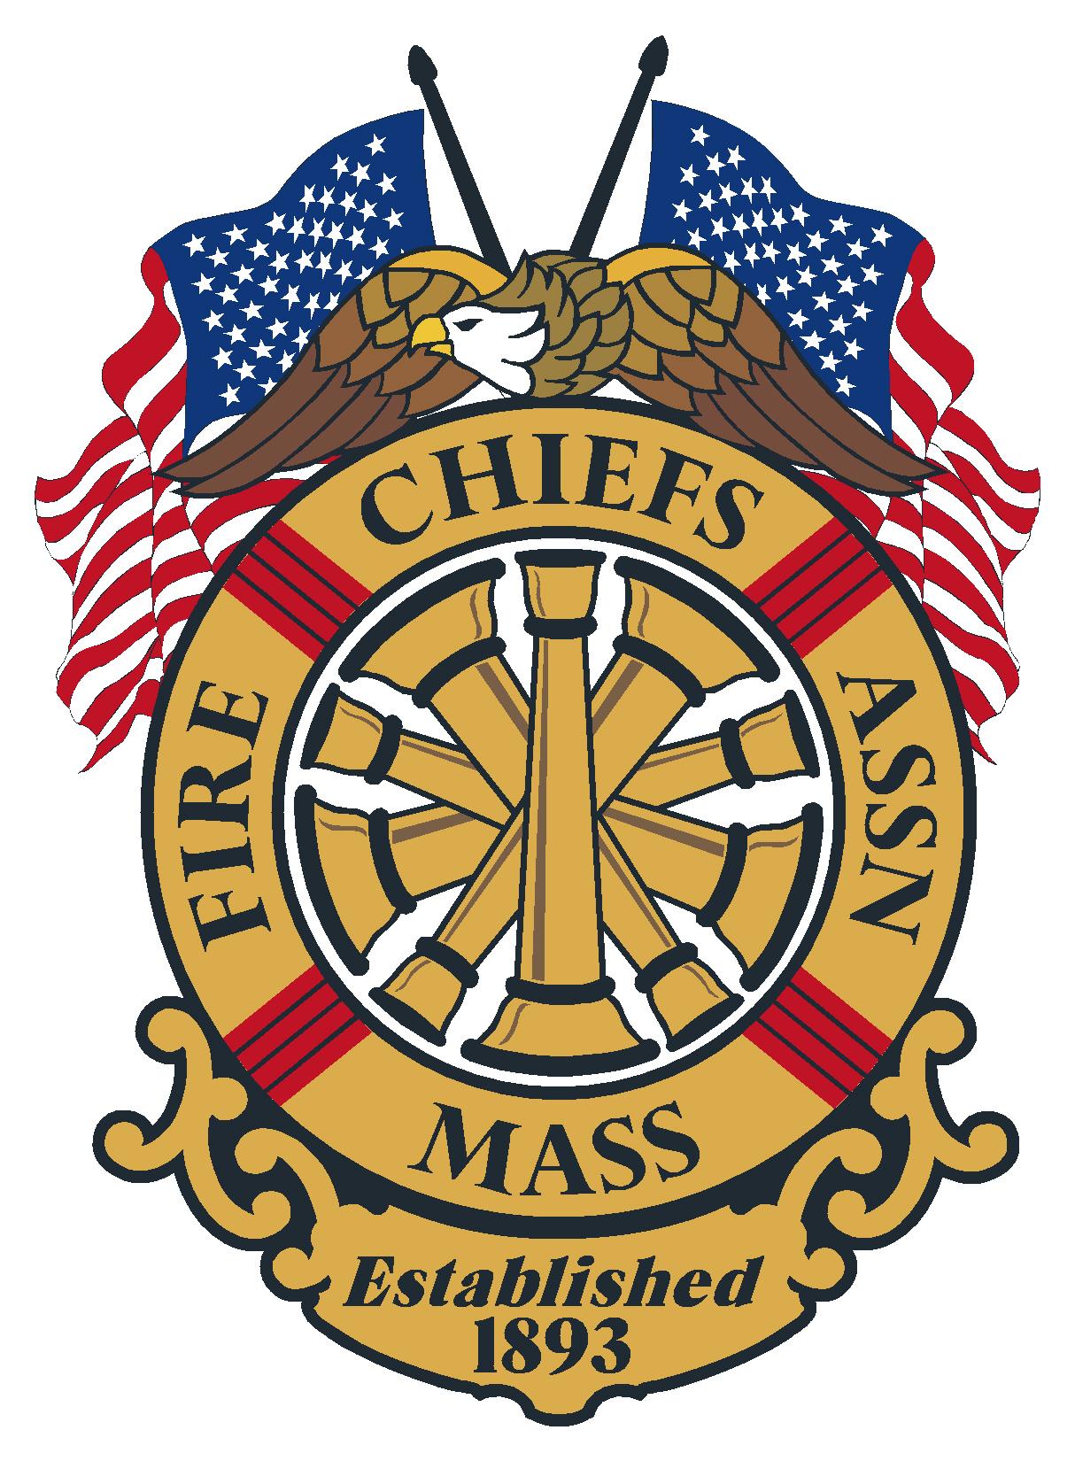

***General Membership Meeting***

***Agenda***

***December 19, 2024, 1230 hours***

***Renaissance Boston Hotel***

***Patriot Place, Foxborough MA***

**Meeting opening**: 1230 hours by Chief Kelleher

**Minutes of the previous meeting:** Minutes of the General Membership meeting held virtually, November 20, 2024. Emailed to membership

Vote:

**Applications for Membership**

* Chief Joseph Hickey, Everett fire Department, Recommended by Chief Keith stark, Weymouth FD
* Chief Jason Perry, Berkley Fire & Rescue Department, recommended by chief Kevin Partridge Ret. Easton
* Deputy Chief Kenneth Sellers, Oxford Fire Department, recommended by Chief Stephen Coleman, Auburn FD
* Chief Roy Liard, Millville Fire Department, recommended by Chief Stephen Coleman, Auburn FD

Vote:

**Application for Life Membership:**

* **Chief Raymond Goodwin, Ret. Onset FD,** recommended by Chief Scott Duffy, Rockland FD

Vote:

**Possible reports by Leadership:**

Chief Mike Kelleher – President

Chief Patrick Purcell – 1st VP

Chief Brian Nardelli – 2nd VP

Chief Peter Burke – IPP

***Remarks for the Good of the Association***

* *CFSI-February 12-13, 2025*

**Moment of silence for FCAM Chiefs whom we have lost in 2024.**

* Chief Joseph Surprenant Ret. Wilbraham Fire Department
* Chief Nelson Harris, Ret., North Reading Fire Department
* Chief Carl Vitagliano, Ret., Braintree Fire Department
* Chief Lawrence Hatch Hampden Fire Department
* Chief Bill Cullinane, Ret., Dedham Fire Department
* Chief Alphee P. Levesque Jr. Ret., Shirley Fire Department
* Fire Chaplain Rev. David Cote, Gardner Fire Department
* Chief Frederick Dusseault Ret. Hudson Fire Department
* Chief Thomas F. Gorman, Ret. Quincy
* Chief Rev. Allen P. Hoyt Ret. Hanson Fire Department
* Chief Edward B. Reilly, Ret. Newton Fire Department

**Next regularly scheduled meeting:**

January 15, 2025- Virtual meeting

**Meeting Adjourn at:**