It is the intention of Easthampton Fire Department to abide by the rules and regulations regarding EMS personnel vaccination against influenza and COVID-19 as outlined in 105 CMR 170.341, 105 CMR 170.342, and any related memoranda/advisories. As part of the regulation, services are required to provide all personnel with information about the risks and benefits of both vaccines.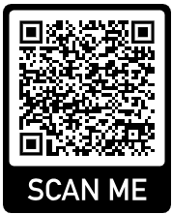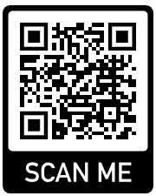 Below you will find

**CDC Information Page MA DPH Information Page**

the two QR codes providing information on the risks and benefits of both vaccines. This form is to create documentation that the below listed individual has received information about the risks and benefits of influenza and COVID-19 vaccinations.

____________________________________________________________________________

**Statement of Understanding**

I, _______________________________, attest that I have been given information about the risks and benefits of the influenza and COVID-19 vaccinations.

_____________ ______________________________

**Date** **Signature**