Fire Chiefs' Association of Massachusetts, Inc

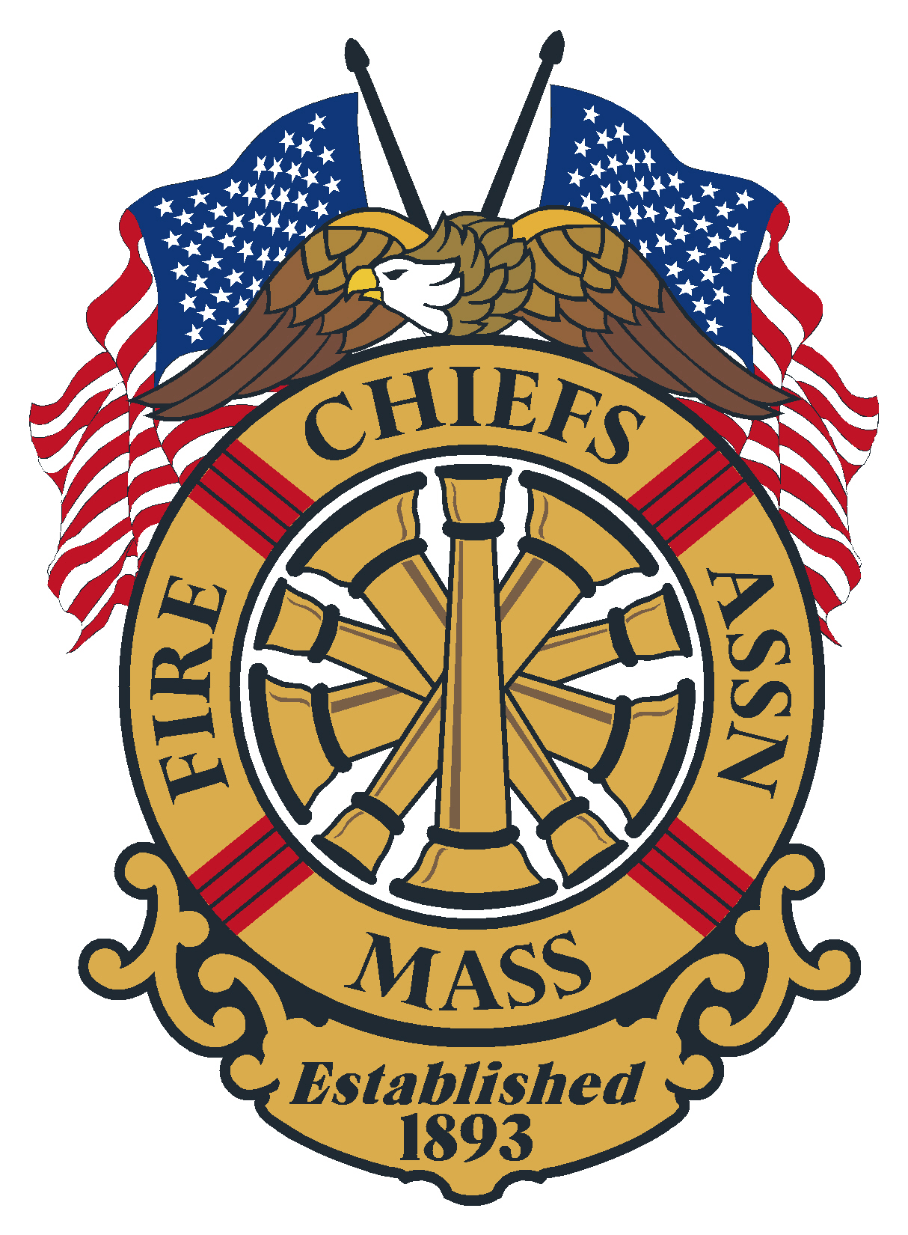

General Membership Meeting
April 24, 2024
Westford Regency Inn and Convention Center, Westford, MA

Meeting opened at: 10:23 AM by Chief Burke

Pledge to the Flag: Chief Burke

Sickness & Distress – Rev. Bruce Arbour

Deaths –
- Chief Bill Cullinane, Ret., Dedham Fire Department
- Firefighter Sander Schultz, Gloucester Fire Department
- Firefighter Nancy Moyer, West Dennis Fire Department

Minutes of the previous meeting: Minutes of the General Membership meeting on March 20, 2024, were sent out to the membership via the FCAM New Flash.
Vote: Approved

Candidates running for 2nd VP to make brief remarks
- Chief Chris Norris, Easthampton Fire Department
- Chief Brian Nardelli, Brockton Fire Department

Applications for Membership

- Chief James L Bailey, Jr. Bedford Fire Department, recommended by Chief Robert Jefferson, Ret., Arlington Fire Department
- Chief David Charest, Avon Fire Department, recommended by Chief Kevin Partridge, Ret., Easton Fire Department
- Chief Richard Fasoli, Southampton Fire Department, recommended by Chief Patrick Egloff, Westfield Fire Department
- Acting Chief Todd Evans, Medford Fire Department, Recommended by Chief Dennis Sencabaugh, Lexington Fire Department
- Chief Daniel Baldwin, Westport Fire Department, recommended by Chief Richard Arruda, Dartmouth Fire District 3
- Deputy Chief Mark Brisk, Westport Fire Department, recommended by Chief Daniel Baldwin, Westport Fire Department
Vote: Approved
Application for Life Membership:
- None

Chief Peter Burke – President - Election
- We have 19 positions to be voted for today. All but the position of 2nd VP is uncontested. I would like to address the uncontested positions first.

Following is the current uncontested Slate of Officers and Directors for FCAM’s FY/25:

President | Chief | Kelleher
1st VP | Chief | Purcell
2nd VP | Chief | To Be Determined
IPP | Chief | Burke
Sec/Treas | Chief | Partridge
D1 | Chief | LeBlanc
D2 | Chief | Duffy
D3 | Chief | Arruda
D4 | Chief | Bailey
D5 | Chief | Alan Dionne
D6 | Chief | McCurdy
D7 | Chief | Coleman
D8 | Chief | Hurlbut
D9 | Chief | Young
D10 | Chief | Spanknebel
D11 | Chief | Bernat
D12 | Chief | Pedercini
D13 | Chief | Stark
D14 | Chief | Ferschke
D15 | Chief | Valentine

- According to the by-laws, elections and balloting are at the April meeting and the inductions of the new officers are at the May meeting. If a single nomination exists for any office, a motion, "Have the Secretary cast one ballot for the nominee” may be in order.
- Seeing there are no contested positions, and if there is no objection, a motion to have the Secretary cast one ballot for all Nominees seems to be in order:
Vote: Approved
- Seeing we have the position being contested for 2nd VP we will hold a written ballot election. Current Fire Chief and retired Fire Chief that are current life members that their dues is paid to date, are eligible to vote.
- Ballots can be picked up at the back of the room, see Chief Parow
- Ballots need to be returned to the ballot box, also at the back of the room, see Chief Partridge
- After all votes are cast, the meeting will resume, and the outcome will be announced later in the meeting.
NOTE: Chief Nardelli from Brockton was elected as FCAM’s 2nd VP

Chief Peter Burke – President
- Discussed the Strategic Plan moving forward

Chief Michael Kelleher – 1st VP
- Survey from on Mental Health from the Marshal
- Ambulance Coalition
- Migrant issue – starting to see public information requests from the news media

Chief Patrick Purcell – 2nd VP
- OSHA
- Vaccine being offered to Firefighters – in 2025 OEMS will be enforcing the mandatory vaccination requirement.

Chief Jim Vuona – IPP
- Mentoring Program

Secretary/Treasurer – Chief Jack Parow, Ret.
- Next Month, May 22, 2024, we will have the formal swearing in of the new slate of Officers at the Lakeview Pavilion, Foxborough. All those attending the meeting are asked to dress in Class As

Treasury
As of April 23, 2024
Citizens Bank:
- Checking $ 47,192.72
- Money Market 1 $ 194,083.69
- Money Market 2 $ 62,995.86
- Legal Defense $ 24,701.00

Assets Citizens Bank = $328,973.27

Chase Bank:
- Checking $ 1,000.00
- CD 1 6 month $129,072.36
- CD 2 12 month $125,000.00

Assets Chase Bank = $255,072.36

Total assets: $ 584,045.63

Vote: Approved

FY 2025 Annual Budget to be voted on
- Approved by the Board of Directors at the March 7, 2024 meeting (FY/25 budget also included in the agenda news flash email)
  - FY/2024 Actual = $316,891.94

  - FY/2025 Proposed = $358,193.97
The major increase was the hiring of a Professional Lobbyist for $42,000.00.

Needs a vote of the General Membership
Vote: Approved

Government Affairs Director- Chief Gene Doherty, Ret.

- The House Budget has been released – The DFS Line is fully funded, the On-Site Academy is fully funded with all the restrictive language (specific to Fire, EMT’s, Corrections Officers) has been removed. What is missing is the earmark for the SAFE program. After checking with the Fire Marshal and his staff, it was confirmed that the funding for SAFE is in the Budget, it’s just the enabling language that’s missing. I spoke with the EOPSS legislative liaison – Tom Ashe- to see if they were going to contact the House Chair of Ways and Means to request a technical change to reinstate the language, and he refused. I spoke with the PFFM legislative agent, and we agreed on a sponsor – Jessica Giannino from Revere. I called AGAD Doherty, and he forwarded the needed language to Rep. Giannino for a Budget Amendment. She has filed it and we will make sure we make phone calls to have it adopted. If there are any problems, we will make sure it’s included in the Senate version of the Budget.
- Many Earmark Amendments have been filed for the Budget – there are 58 regarding the fire service, including the one for SAFE, 2 for counties, one for the JLMC, one for training for HazMat team members, one for EMS Councils, one for Western Mass Juvenile Fire Setting Intervention and 51 for local communities.
- All of our priority Bills that sit within the Public Safety Committee have been put on a second Extension Order – now sitting at May 8th. There are philosophical differences between the House and Senate Chairs of the Committee, and it is holding up the release of the Bills.
- On other Bills – the ambulance reimbursement Bills have been sent off to study – effectively killed. However, we were already working with the Ambulance Coalition to come up with better language that reflects Bills that passed overwhelmingly in California, Texas, and New York. The plan is to attach the language as an outside section of a larger Bill coming out from the Health Care Finance Committee.
- A Bill to exempt retirees from hour and wage limitations working for DFS has been reported favorably out of the Public Service Committee and has now been ordered to a Third Reading. This is a better Bill than the original that only exempted hours. This one also encompasses police officers working for the MPTC so it has wider support.
- Likewise, the Jack Chandler Bill addressing creditable service time was reported out favorably and is now on the floor and ordered to a Third Reading.
- Two other Bills that are moving forward – HB 4545 would create a State Disaster Relief Fund following in the wake of the flooding in the Leominster area – and SB 1592 by Senator Bruce Tarr would require that Fire Chiefs have a minimum of 5 years of experience in Massachusetts to be appointed to that rank. “Fire chief qualifications; work history of candidates for fire chief: No person shall be eligible to be appointed to the position of Fire Chief, and/or Fire Commissioner, and/or Head of a Fire Department in any City, Town or Fire District within the Commonwealth unless said candidate has been a uniformed member of the Massachusetts firefighting force of a Massachusetts Fire Department for a minimum of five years.”
- I received a call from the Norwood Town Manager regarding the Stewart Hospital closure issues, and the fact that the regional meetings are closed and there is no local voice on the Committee studying the issue. We discussed possibilities and after our discussion I called Bill Cass, not only is he the lobbyist for the Ambulance Coalition but he’s also the lobbyist for steward Healthcare. He suggested Chief Tim Bailey from Norwood Fire as a representative, and that he would contact a key member of the legislature to try to make that happen. Bill Cass followed up last week to tell me that this is in the works and is viewed favorably.
- I attended the Western Mass Legislative Luncheon on April 12th, there was great representation from both the Chiefs and the legislature. The Chiefs did presentations on ambulance billing, residential sprinklers and the Public Safety Building Authority. Towards the end of the meeting Senator Commerford texted me to ask to meet regarding the PSBA – we will set up the meeting.
- The Bristol County Legislative Clam Boil will be held on May 8th.
- I attended an event for Representative Meghan Kilcoyne on April 10th.
- Gene attended an event for representative Jessica Giannino on April 15th.
- We have 57 Chiefs plus the Fire Marshal going to Washington for our Congressional Delegation Breakfast, and about 39 of them are attending the CFSI event. There will also be six representatives from the IAFC joining us thanks to Chief Stark. The CFSI events and dinner are all on Monday the 29th, and the Breakfast and majority of the individual meetings with Members of Congress are on Tuesday the 30th. Gene has been tenacious working to set up the individual meetings. As of now, we have meetings with 6 of the nine of our Congressmen/Women.
- I have constantly spoken about the lack of action coming out of the legislature – here is a comment taken from our legislation tracking reporting software:
Now that we’re in mid-April, we’re just over 100 days into 2024 and just over 100 days until July 31, i.e., the last day of the formal period of the legislative session. So what’s happened in 2024 so far? 74 bills have been signed into law in 2024: 44 are about just 1 town. 17 are about just 1 city. 12 are about just 1 person. That totals 73 out of the 74 being about 1 town, 1 city, or 1 person. And that 1 other bill? It’s about 2 towns.
The Massachusetts legislature got off to a historically slow start in 2023 and that lack of urgency has continued to the finish line in 2024.
State Fire Marshal – Jon Davine
- Unable to attend

Reports of Special Committee

Civil Service – Chief Stark
- Municipal Firefighter Eligible list was established/merged 4/1/2024. Certifications from the list will begin to be issued shortly.
- Statewide Fire Lieutenant and Captain exams will be administered on 4/27/2024.
- 2024 Fire Chief (May) written exam will be administered on 5/1/2024 with the Assessment Center component administered on 5/4/2024.
- 2024 Boston Deputy Fire Chief Exam Reading List announced and now available. We will begin accepting applications on 4/16/2024 through 5/17/2024. The exam is scheduled to be administered on 6/8/2024.

IAFC – Chief Stark
- IAFC voting opens May 14th and ends June 18th. Please vote when you receive your ballot via email. It only takes a minute
- FCAM endorsed Chief Steve Locke from VT., The current IAFC Treasurer
Haz Mat – Chief Bailey

EMS – Chief Norris

Tech Rescue – Chief Mansfield

Fire Mobilization – Chief Hurlbut
- Meeting May 29th
Call/Volunteer – Chief Maruca

State 911 – Chief Kelleher

DEI Committee – Chief Kelly
- Met with the Marshal
- Next meeting June 26th
Utilities – Chief Nardelli

Unfinished Business
- Website – Chief Partridge – change over June or July 2024
- PDC – Chief Partridge – Save the Date February 25-27, 2025

New Business

Remarks for the Good of the Association
- IAFC Fire Rescue International August 14-16, 2024, Dallas, TX
- NEAFC Expo Mohegan Sun October 16-18, 2024

Next regularly is scheduled meeting:
- May 22, 2024, GM Installation of Officers meeting. At the Lakeview Pavilion, 45 Lakeview Road, Foxborough, MA

Meeting Adjourn at: 11:55 AM

