Fire Chiefs' Association of Massachusetts, Inc

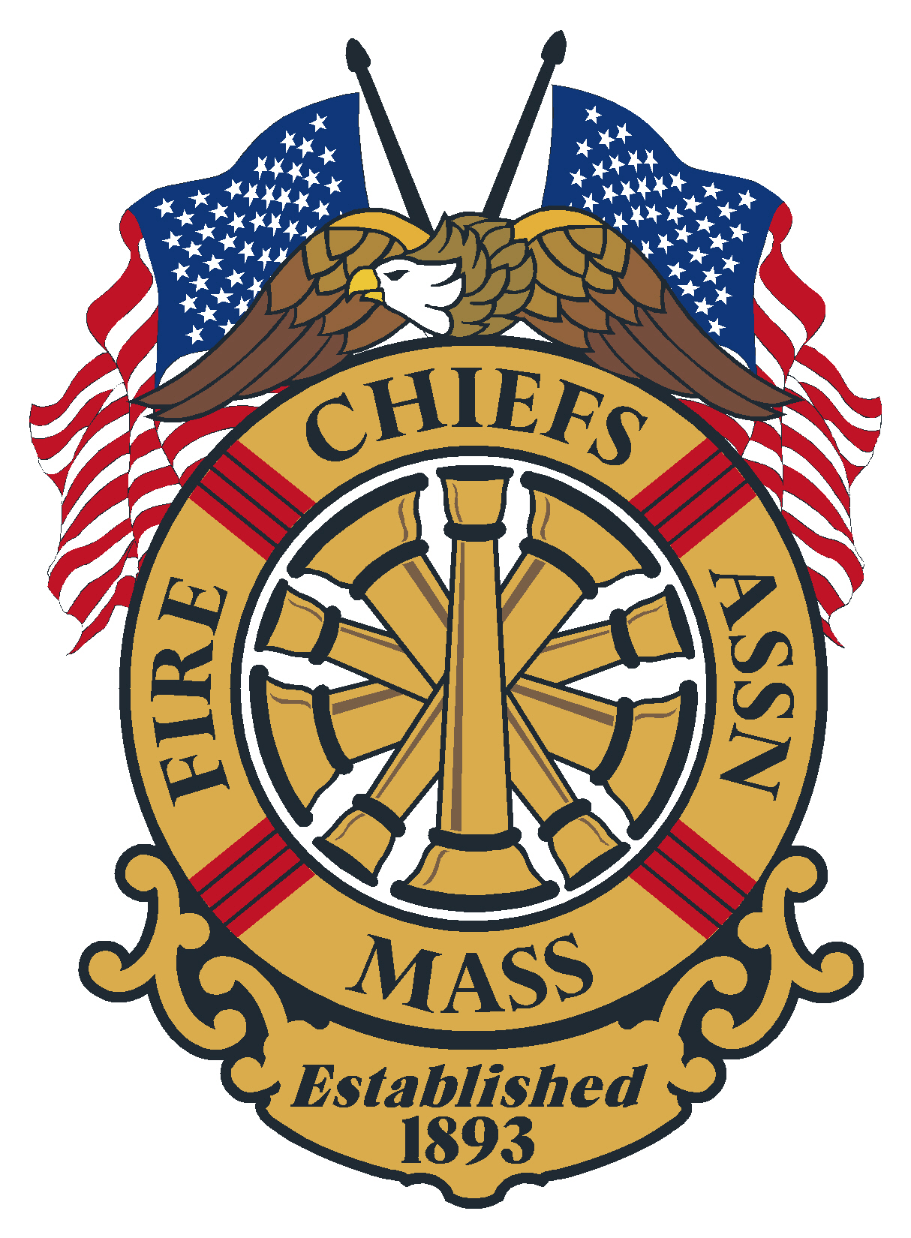

General Membership Meeting
Agenda
June 26, 2024
Anna Maria College, 50 Sunset Lane, Paxton, MA

Meeting opened at: by Chief Kelleher

Pledge to the Flag:

Invocation - Rev. Bruce Arbour

Sickness & Distress –

Deaths –
- Boston Fire Chaplain Emeritus Fr. Daniel J. Mahoney
- Retired Fire Chief Robert J. Koning Carlise Fire Department
- Retired Fire Chief Alphee Levesque Jr. Shirley Fire Department- Veteran of MA National Guard
- Diane Fasoli Mother of Fire Chief Richard Fasoli SouthamptonFire Department

Minutes of the previous meeting: Minutes of the General Membership meeting on May 22, 2024, were sent out to the membership via the FCAM New Flash.
Vote:

Applications for Membership

- Chief Steven Lavigne, Taunton Fire Department, recommended by Chief Richard Arruda, Dartmouth Dist. #2 Fire Department
- Deputy Chief Brian Hayes, Weston Fire Department, recommended by Chief Justin Woodside, Weston Fire Department
- Deputy Chief Patrick Hill, C.O.M.M. Fire Department, recommended by Chief Mike Winn, C.O.M.M. Fire Department
- Chief John Schlatz, Bridgewater Fire Department, recommended by Chief Kevin Partridge
- Chief Andrew Putini, Southborough Fire Department, recommended by Chief Mike Kelleher
- Chief John Quatieri, Chelsea Fire Department, recommended by Chief Kevin Partridge
- Chief Kyle Murphy, Andover Fire Department, recommended by Chief Michael Mansfield, Andover Fire Department
- Chief Scott Turner, Great Barrington Fire Department, Recommended y Chief David Mottor retired Easthampton Fire Department

Vote:

Application for Life Membership:
- Chief Michael Mansfield, Andover Fire Department
- Chief W. Tim Leson, Amherst Fire Department
- Chief Michael Winn, C.O.M.M.

Vote:

Chief Mike Kelleher – President

- Migrant Issue
- OEMS

Chief Patrick Purcell – 1st VP

- Committees/Commissions
  - Training Council needs a combination Chief
- OSHA

Chief Brian Nardelli – 2nd VP

- Utilities

Chief Peter Burke – IPP
Secretary/Treasurer – Chief Kevin Partridge, Ret.
- The Transition has been going good, new bank accounts established, legal documents completed, new PO Box established.
  - Same email for Sec/Treas. And same office phone
- Dues notices will be going out early July, reminder to let your treasurer/accountant know that the address for the association has changed. A new W-9 was put out.
- New Website continues to come along.
- PDC- manger selected, Congratulation to Russ Anderson, PDC is Feb 25-27, 2025
- Next meeting is September 18, 2024

Treasury
As of June 19, 2024
Citizens Bank:
- Checking $ 8,103.63
- Money Market 1 $ 0
- Money Market 2 $ 0
- Legal Defense $ 0

Assets Citizens Bank = $ 8,103.63

Baycoast Bank:
- Checking- Operating $ 20,267.27
- Money Market 1 $220,778.71
- Legal Defense $ 25,500.00

Assets Baycoast Bank= $ 266,545.98

Chase Bank:
- Checking $ 1,000.00
- CD 1 6 month $129,072.36
- CD 2 12 month $129,698.52

Assets Chase Bank = $259,770.88

Total assets: $ 534,420.49
Vote:

Government Affairs Director- Chief Gene Doherty, Ret.

State Fire Marshal – Jon Davine

Reports of Special Committee

Civil Service – Chief Stark

IAFC – Chief Stark

Haz Mat – Chief Bailey

EMS – Chief Norris

Tech Rescue –

Fire Mobilization – Chief Hurlbut

Call/Volunteer –

State 911 – Chief Kelleher

DEI Committee – Chief Kelly

Utilities – Chief Nardelli

Unfinished Business

New Business

Remarks for the Good of the Association
- IAFC Fire Rescue International August 14-16, 2024, Dallas, TX
- NEAFC Expo Mohegan Sun October 16-18, 2024
- FCAM PDC February 25-27, 2025

Next regularly is scheduled meeting:
- September 18, 2024, Arturo’s Ristorante, 54 E. Main street, Westborough

Meeting Adjourn at:

